Bahria University

Karachi Campus



COURSE: Computing Fundamentals

TERM: FALL 2022, CLASS: BSE- 1 (C)

COFFEE SHOP MANAGEMENT SYSTEM

Submitted to: Engr. Rahemeen Khan

Signed Remarks: Score:

TEAM MEMBERS

***AYESHA (02-131222-090)*** *(Team lead)*

***SYED UMER ALI (02-131222-027)***

***HAFSA SHAHID (02-131222-088)***

***IQRA ZAMAN (02-131222-026)***

**Table of Contents**

INTRODUCTION 3

PROBLEM 3

TECHNOLOGY 3

SCOPE & ABSTRACT 3

FUNCTIONALITIES 4

MODULE DISTRIBUTION 4

INTERFACES 5

RESULT 8

CONCLUSION 8

REFRENCES 9

### 

### INTRODUCTION

Abstract-Coffee Shop Management System is based on a concept to maintain orders and management of a particular coffee shop. There are two sections in this project, they are Coffee Ordering and Admin panel. By using this system, he/she can maintain ordering records of a day. By selecting Coffee Order the system displays a list of Available coffee drinks and the user must place an order with item quantity. After that, he/she precedes towards Order confirmation and Payment methods.

The aim of this document is to gather and analyze and give an in-depth insight of the complete Coffee Shop Management. This system will help to automate the work and make it easier for the manager or owner of a coffee website.

### PROBLEM

The project is beneficial only if it can be turned into an information system that will meet the organization operating requirements. This test of feasibility asks if the system will work when it is developed and installed. The proposed system is easily adapted by the users and the proposed system is bound to improve the overall performance, it is operational feasible to develop and implement the system.

### TECHNOLOGY

The proposed system can run on any machines supporting Windows or Mac and works on the best software and hardware that had been used while designing the system so it would be feasible in all technical terms of feasibility. Additionally, HTML and CSS languages have been utilized to make this project accomplished and the Integrated Development Environment of **Microsoft Visual Studio Code** has been used.

### SCOPE & ABSTRACT

This system will help to manage and run the coffee shop systematically. In this management system, we will provide a website that can be used by customers to check menu, address and also for giving order. So the owner of shop can evaluate the whole system. This will ultimately lead to hire less employees to place and check orders and create an opportunity to appoint more chefs and better shop to serve coffee faster.

The main purpose of preparing these documents is to give a general insight into the analysis and requirements of the existing system or situation and for determining the operating characteristics of the system. This project is designed in such a way that it will generate the bill automatically every order in time. So there will not be much worries about placing orders. This will also keep records of customers and number of placed orders.

### FUNCTIONALITIES

Following functionalities have been added to this project:

• Attractive website for advertisement

• Ordering system

• Displays total bill or invoice

• Add and delete coffee items

• Item counter

• Instant order preview

Coffee Shop Management software is the need and necessity of every organization and its human resource systems. With Coffee Shop Management System, the customer’s information and their details are efficiently managed to satisfy the needs of both the customers and management.

### MODULE DISTRIBUTION

We divided the working of our project among the members. Each

member worked on his/her module sincerely.

**Ayesha:** (02-131222-090)

Front designing of website (pictures exploration) and designing of

forms of database access (Adobe Stock, 2022)

**Hafsa Shahid:** (02-131222-088)

Advertising website (using HTML & CSS) (Kandi, n.d.)

**Iqra Zaman:** (02-131222-026)

Main work of placing order system in database access and

management of record through tables. (Gichai)

**Syed Umer Ali:** (02-131222-027)

Documentation (report making) and attachment of database access’s

project to website through link. (Document360)

### INTERFACES

Website interfaces (html & css)

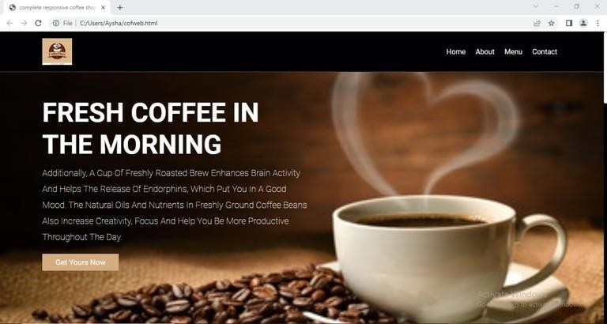When any user/customer enters the url of our website, so the home page looks like below:

When user click on the about button, website redirect the user to "About

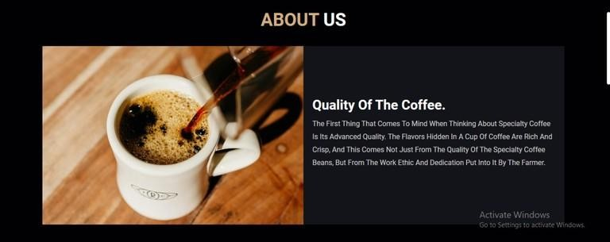us" section, which looks like this

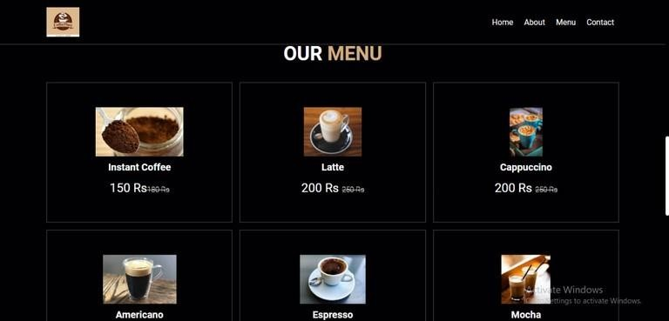 The menu of products i.e. coffee appears like this on the website:

When user clicks on "order now" or "get yours" button, the admin of the website directs the user to order from where customer/user has to select the coffee type and quantity.

MS Access interfaces

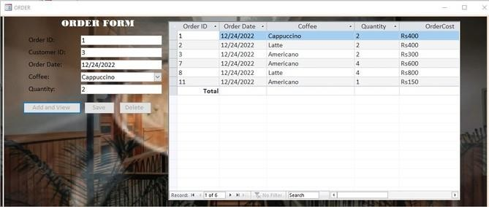

Customer will be provided with this type of form at the time of registration

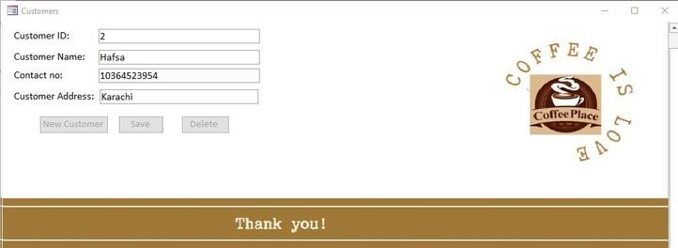

This is the price list stores at MS Access of all types of coffee:

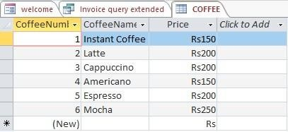

Below is the database of the customers of coffee shop.

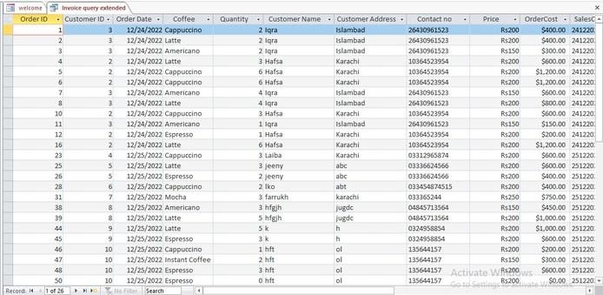

MS Publisher interface (visiting card)

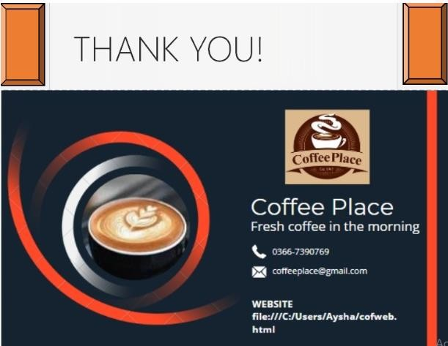

### RESULT

* The system is developed with the intrusion of future expansion of the concern.
* The concern can go for any future developments, as per their needs. If so, they can easily develop the modules and integrate with the existing system.
* New menus can easily be added since it is highly user friendly.
* The system is fully menu driven and hence menus can be added as required
* Totally the system can be accommodated for any type modification.

### CONCLUSION

* The project entitled “COFFEE SHOP MANAGEMENT SYSTEM” has been proposed to be implemented to replace the manual system.
* The developed system accomplishes all the objectives stated for the need for the change of the system.
* The outputs produced seem to satisfy all the users but it will definitely take time to look forward to the real consequences the new system could produce.
* This project was made user friendly by the use of MS Access enabling the user to interact easily with the database.
* It’s also enabled the platform to serve the needs of emerging information technology trends and needs.

### REFRENCES

# Bibliography

(n.d.). Retrieved from Kandi: https://kandi.openweaver.com/search?q=html+and+css+website

(n.d.). Retrieved from Document360: https://document360.com/blog/project-documentation/

(2022). Retrieved from Adobe Stock: https://stock.adobe.com/search?k=coffee

Gichai, D. (Director). (n.d.). [Motion Picture]. Retrieved from https://www.youtube.com/watch?v=e0aMWynh-pQ&t=312s